Church Lane Primary School & Nursery Packed Lunch Policy

Overall aim of the policy:

To ensure that all packed lunches brought from home and consumed in school (or on school trips) provide pupils with healthy and nutritious food that is similar in quality to food served in schools, which is required to meet national standards.
Where, when and to whom the policy applies:
The policy applies to all pupils and parents providing packed lunches to be eaten within school or on school trips during normal school hours.

At Church Lane Primary School & Nursery, we understand that our pupils benefit from eating a balanced and nutritious diet. Among other benefits, a good diet helps to;
- Keep skin, teeth, and eyes healthy
- Support muscles
- Helps achieve and maintain a healthy weight
- Strengthens bones
- Encourages brain development
- Supports healthy growth
- Boosts immunity
- Helps the digestive system function

In 2015 the School Food Standards for school lunches was published to ensure that all children who eat a school dinner benefit from eating quality food during the school day. The standards apply to all food and drink supplied by school to pupils, staff and visitors from the start of the school day to 6pm.

Food and drink in packed lunches at Church Lane Primary School & Nursery:
- we will ensure that free, fresh drinking water is available at all times.
- we will work with parents to encourage packed lunches to meet the standards listed below.
- As we do not have facilities to refrigerate packed lunches brought from home, we recommend that they are sent in insulated lunch bags or contain ice packs to ensure

- food is kept cool, particularly during the summer months. We are unable to cool or heat food, so please ensure all packed lunch items are ready to eat.
- Wherever possible we will enable pupils eating packed lunches and pupils eating school lunches to sit together.

Packed lunches should include:
- at least one portion of fruit and one portion of vegetables every day.
- meat, fish, eggs, or a non-dairy protein (e.g. lentils, kidney beans, chickpeas, houmous, peanut butter, falafel) every day.
- oily fish, such as salmon, at least once every three weeks.
- a starchy food such as any type of bread (white or wholegrain rolls, pitta bread or wraps), pasta, rice, couscous, noodles, potatoes or another cereal every day.
- a dairy food such as milk, cheese, yoghurt, fromage frais or custard every day.
- a drink of water, fruit juice (maximum portion 150 mls), semi-skimmed, 1% fat or skimmed milk, yoghurt or another milk drink.

Packed lunches can occasionally include:
- Meat products such as sausage rolls, individual pies, corned meat and sausages (no more than once a week)
- Lower sugar cakes and biscuits, but encourage your child to eat these as part of a meal

Appendix 1 & 2 gives guidance on appropriate potential packed lunches which works alongside the School Food Standards and the information above.
The advice is for guidance for parents and Church Lane primary School & Nursery actively encourages meals provided in line with it, however we do not allow the following to be brought into school as part of a packed lunch.

Restricted items
- No fizzy drinks
- No chocolate (cocoa flavoured products are accepted) (optional: a single chocolate covered biscuit bar will be accepted)
- No sweets
- No food from fast food outlets
- A single bag of crisps or other savoury snack packet is acceptable
- No nuts

Assessment, evaluation and reviewing

Packed lunches will be regularly reviewed by teaching staff / catering staff / midday meal supervisors / pre-identified pupil packed lunch helpers.

If a member of staff becomes aware that a child has a fizzy drink, solid chocolate, sweets or food from a fast food outlets in their lunch they will notify the Teacher who will make a note of the child and the food but will not discuss this directly with the child.

If a child regularly brings a packed lunch that does not conform to the policy then the school will contact the parents to discuss this.

Date Implemented: Sept 2026
Review Date: Sept 2027

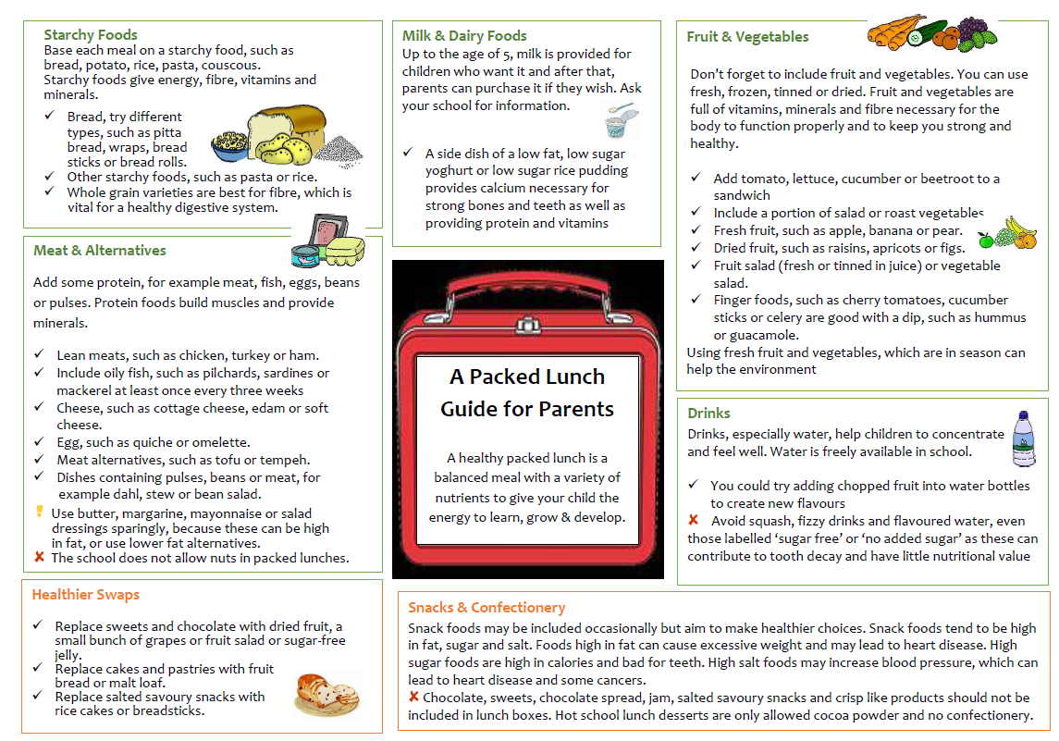
Appendix 1
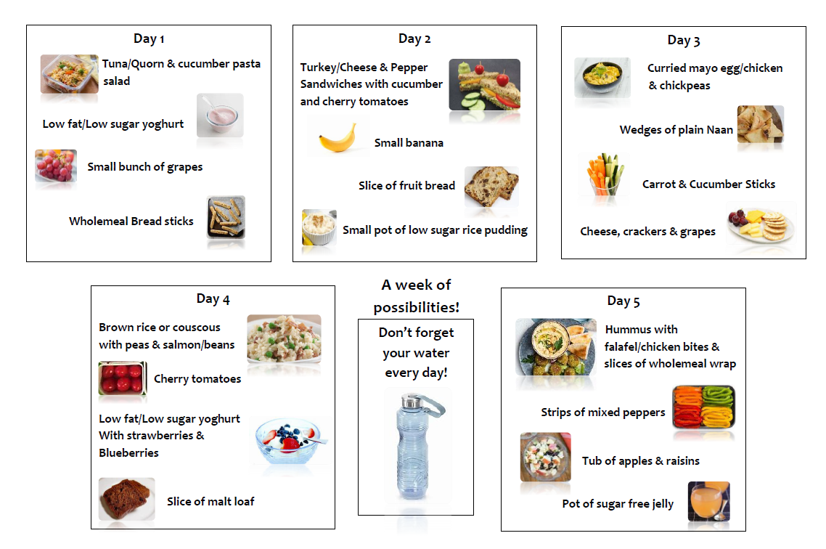
Appendix 2

School food standards practical guide - GOV.UK (www.gov.uk)

